Your EdHockey Robot

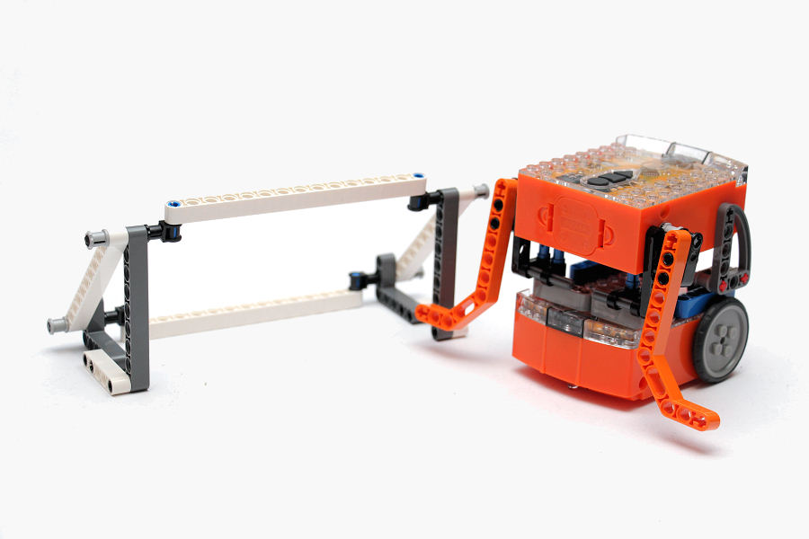You’re a Builder

Introduction
EdBook3 ‘You’re a builder’ follows on from EdBook1 and EdBook2, therefore to complete the following EdVentures, it is assumed that both of these EdBooks have been read. And that how to read barcodes and program Edison using EdWare is well understood.

Compact Tracked Loader
The EdHockey Robot uses parts from the LEGO Compact Tracked Loader (set 42032). This LEGO set is available from mybrick.com.au
It’s a great LEGO set and it is recommended that the model on the front cover is built before starting the EdVentures.

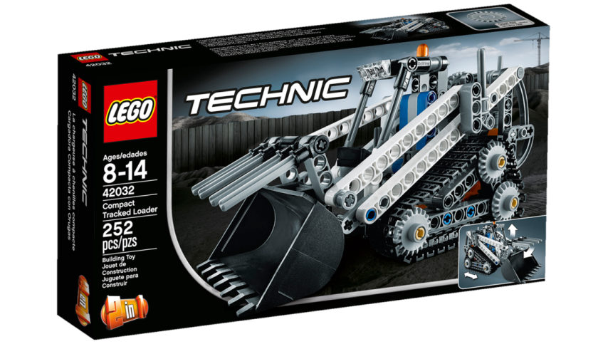

Edison and LEGO compatibility
LEGO bricks can be attached to the top and bottom of the Edison robot and LEGO pegs can be attached on the sides. There are three types of holes on the side of Edison:
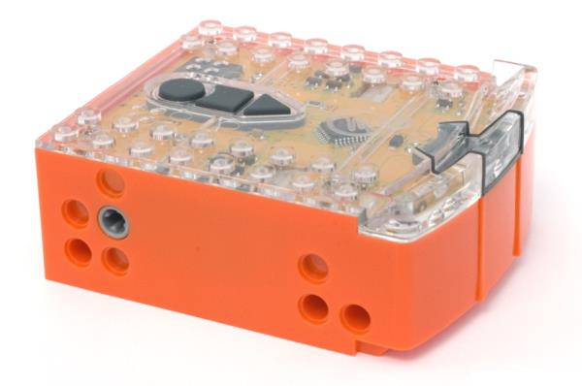
stud hole
stud hole
stud hole
pin hole
powered cross axle socket
2 x pin holes
stud hole
2 x 8 studs
2 x 8 studs
Edison’s side and top LEGO connections

Hole type | Description | Connects to
Pin hole | Full depth for connecting pegs | 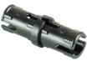
Stud hole | Normal stud depth can be used for half pegs | 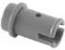
Cross axle | Powered output that rotates | 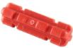
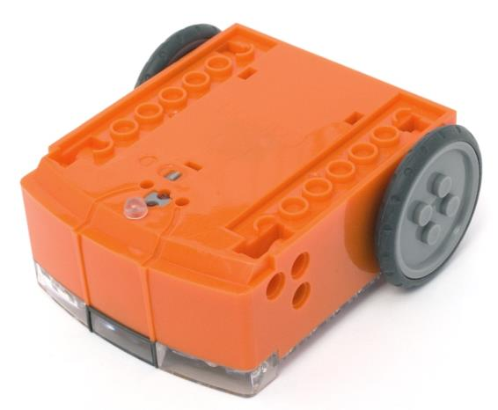
2 x 8 sockets
2 x 8 sockets

Removable skid
2 x 2 studs

Edison’s bottom and wheel LEGO connections

The EdHockey Robot
The EdHockey Robot is a remote control LEGO brick robot that uses two Edisons connected with LEGO pieces from LEGO set 42032. You can use a standard TV/DVD remote control to drive the EdHockey Robot and operate the arms
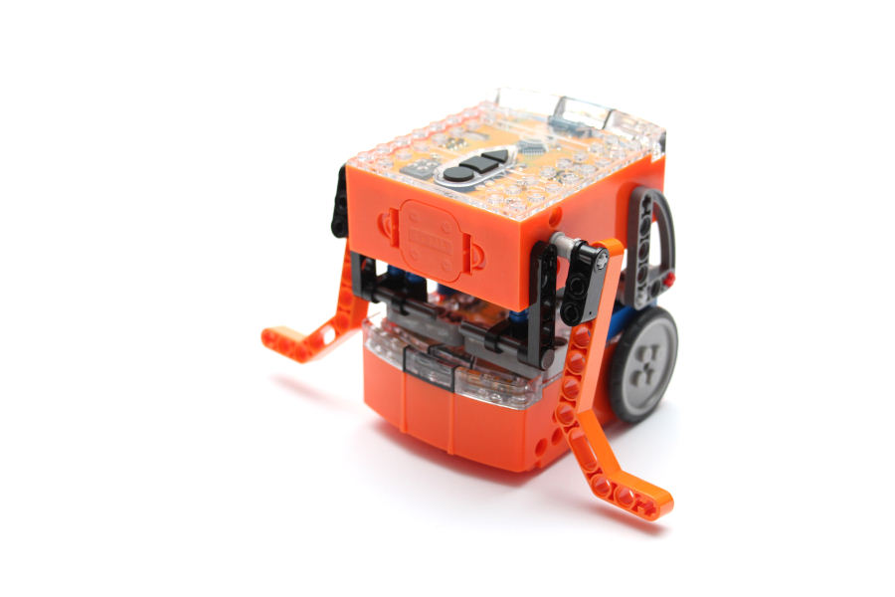
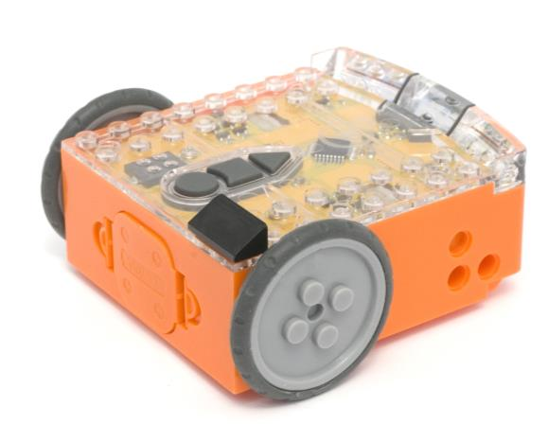

Program the remote control codes
Print the next two pages so you can drive the two Edison robots over the barcodes.
To make this process easier mark one Edison with the black sloping roof tile piece as shown. This Edison will be used as the bucket controller.

Program bucket controller Edison
Drive the top Edison over the following barcodes. Use buttons that correspond well with movement of the arms on the remote control, but don’t use the buttons that you want to drive the EdHockey Robot with. See suggested button arrangement below, although your remote control will likely be different.

Reading the barcode
1. Place Edison facing the barcode on the right side
2. Press the record (round) button 3 times
3. Edison will drive forward and scan the barcode
4. Press a button on your TV/DVD remote that you want to activate that function

Barcode – IR learn bucket up
Barcode – IR learn bucket down

Suggested button setup
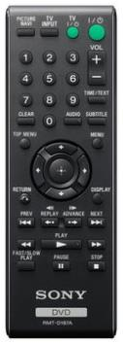
bucket up

bucket down

drive forward

spin right

spin left

drive backward

Program driving Edison
The driving Edison will control the movement of the EdHockey Robot (forwards, backwards, spin left and spin right). Drive this Edison over the following barcodes. Use buttons that correspond well with the driving manoeuvres on the remote control, but don’t use the buttons that you want to control the bucket with.

Reading the barcode
1. Place Edison facing the barcode on the right side
2. Press the record (round) button 3 times
3. Edison will drive forward and scan the barcode
4. Press a button on your TV/DVD remote that you want to activate that function

Barcode – IR learn drive backward
Barcode – IR learn drive forward

Barcode – IR learn spin left
Barcode – IR learn spin right

Assemble the EdHockey Robot
Follow the illustrations to build the EdHockey Robot

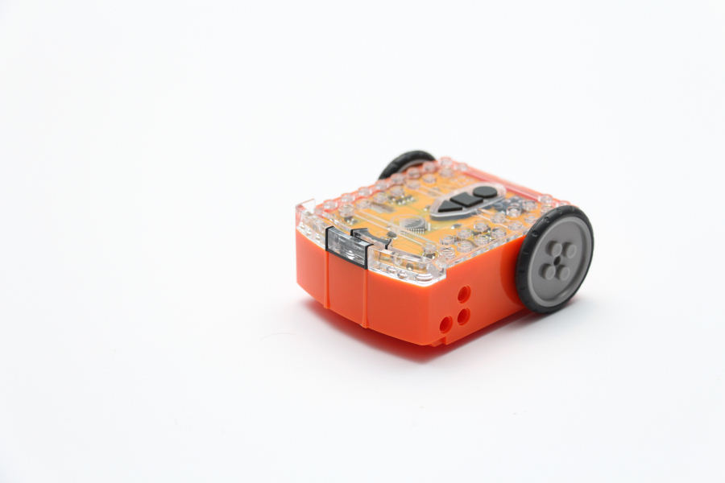
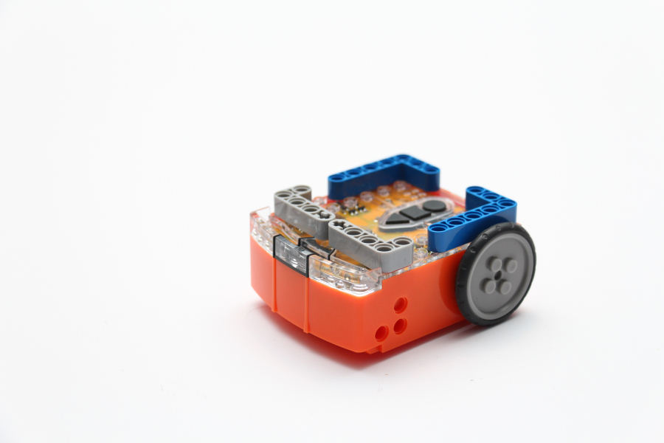
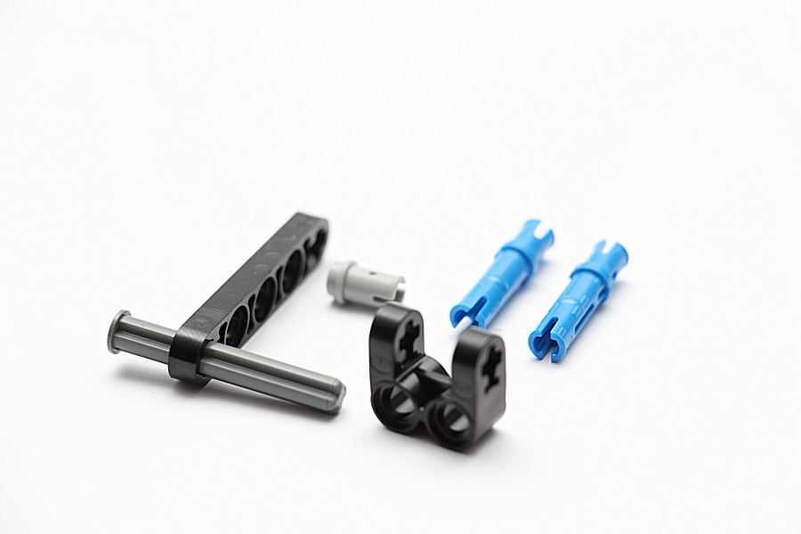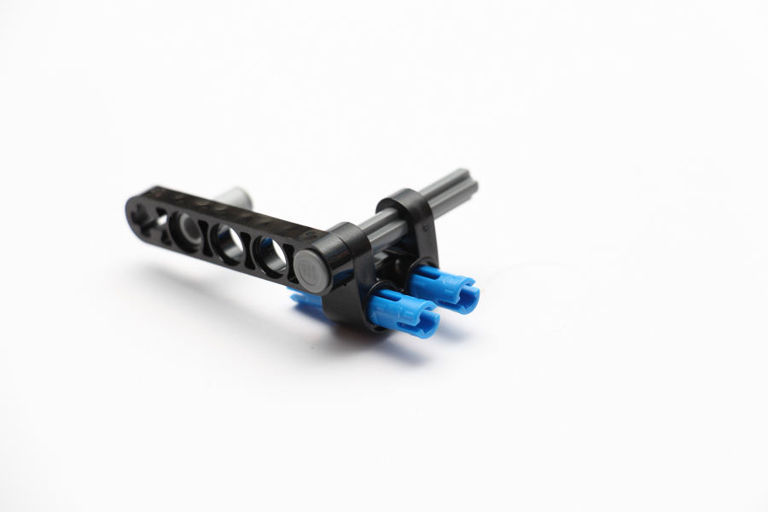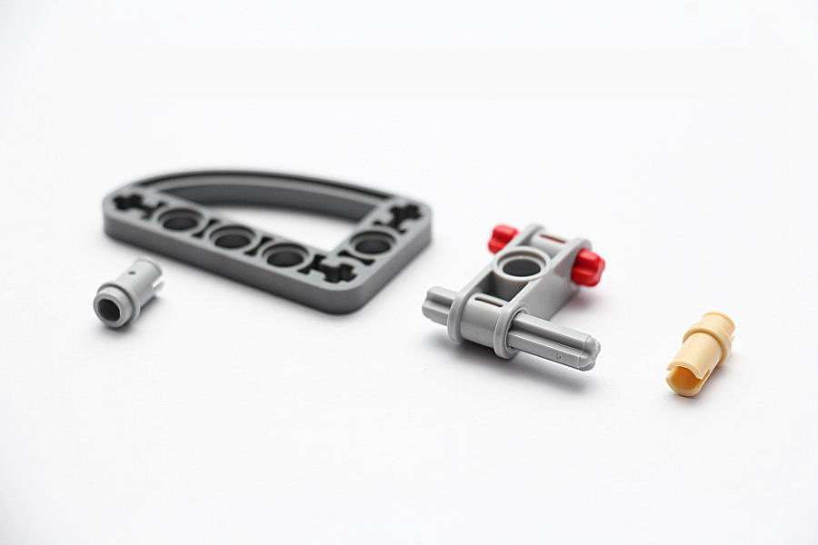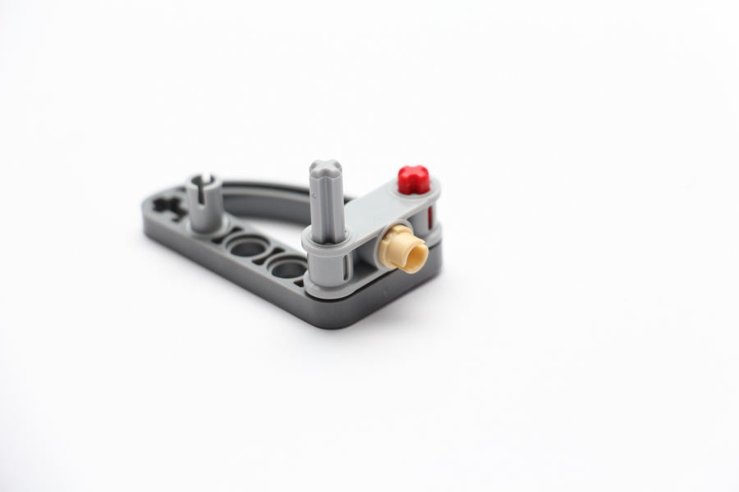

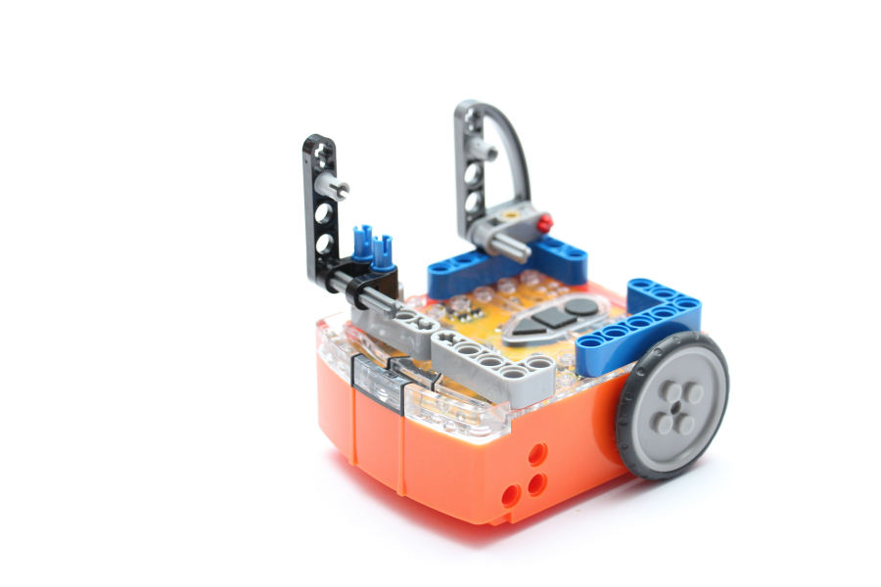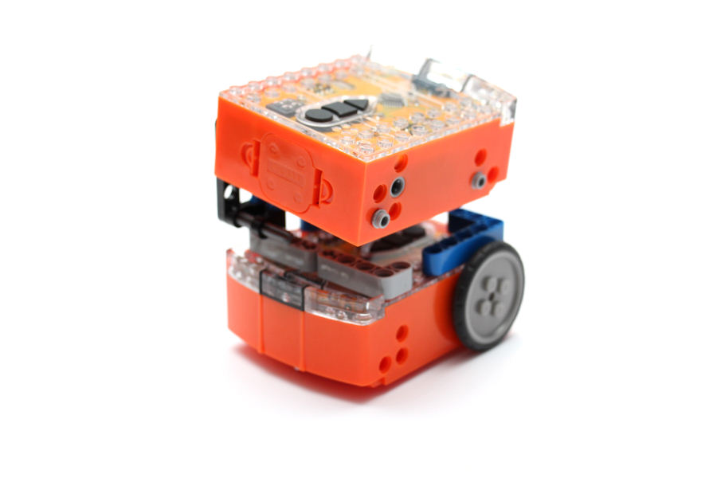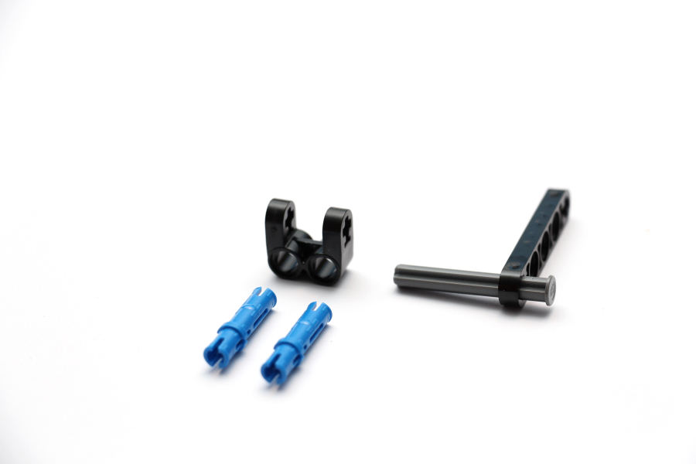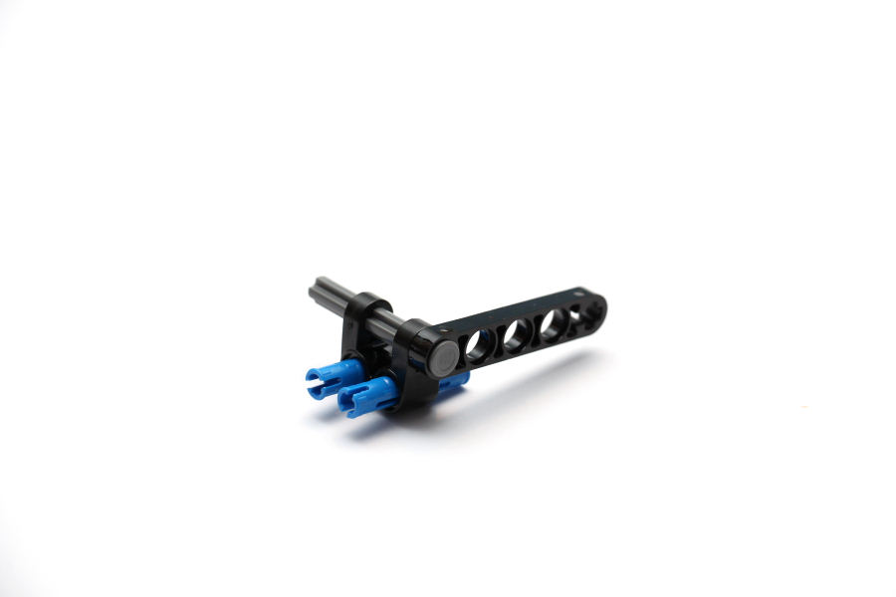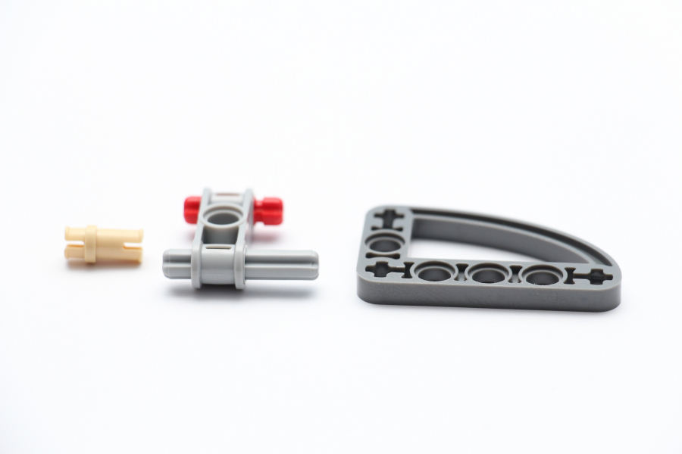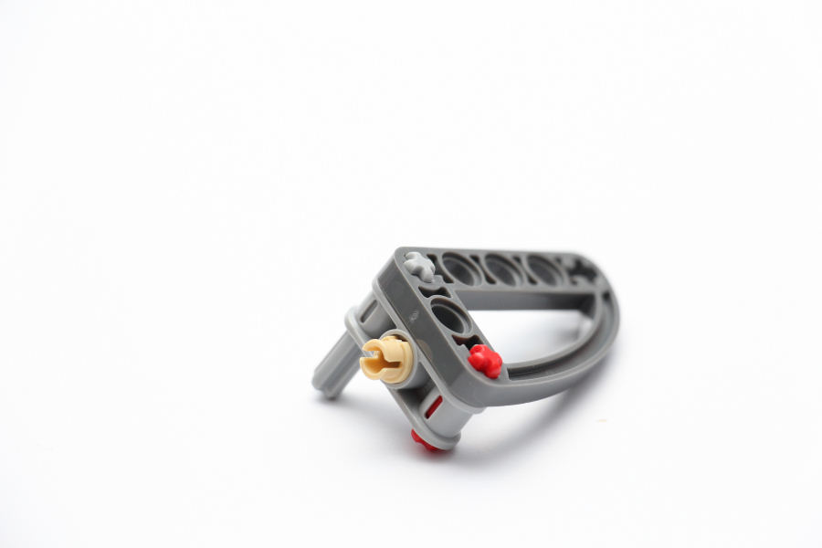

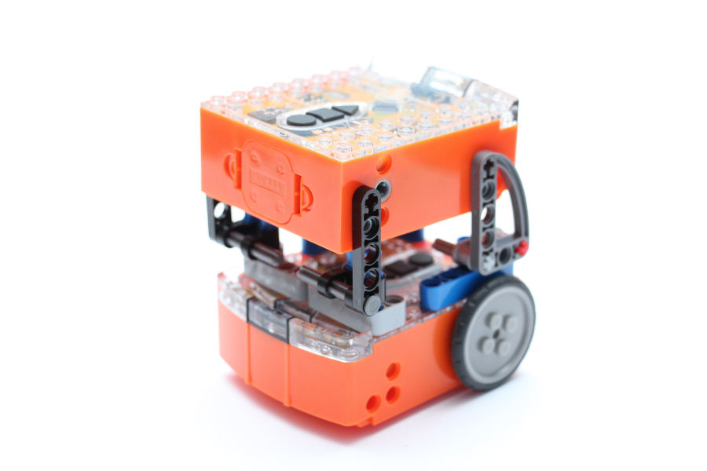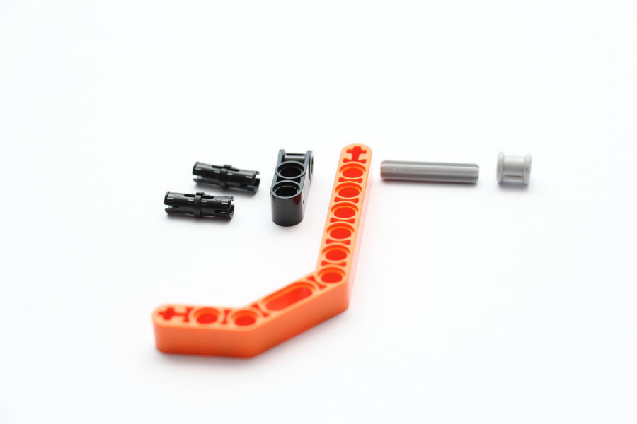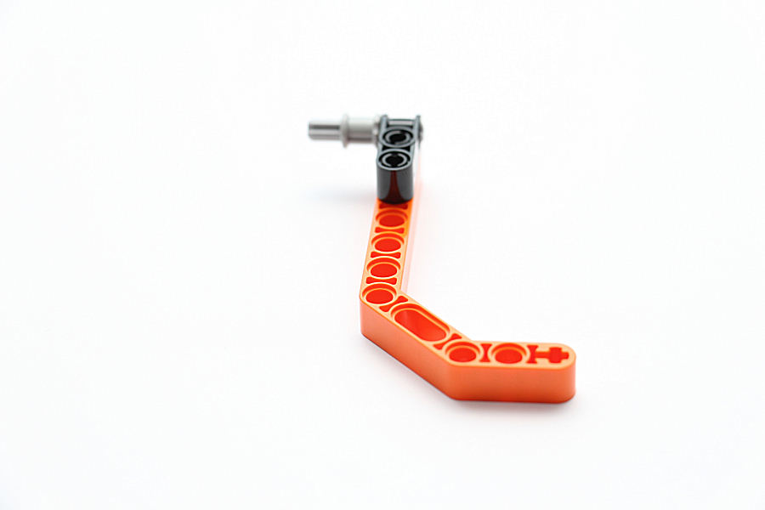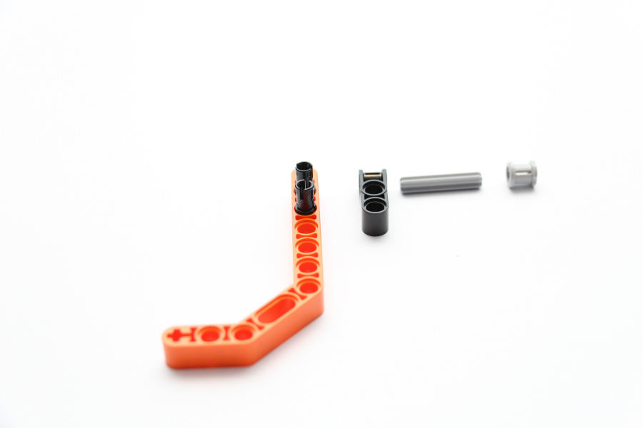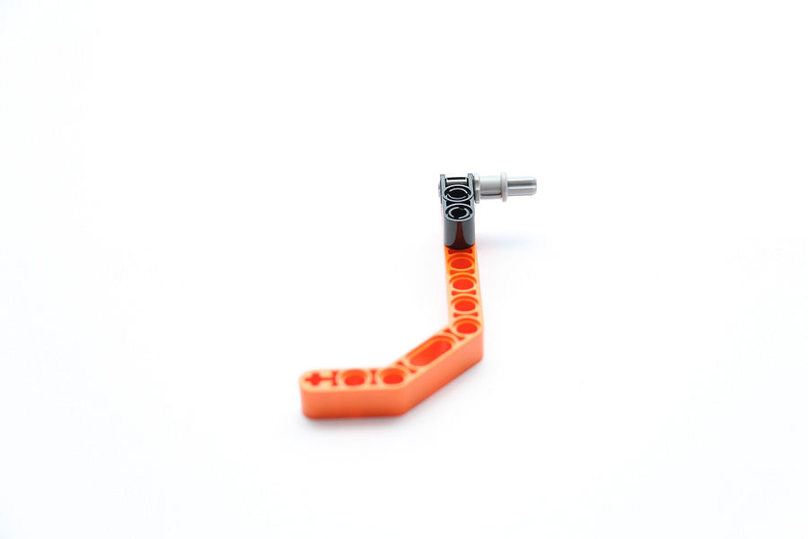

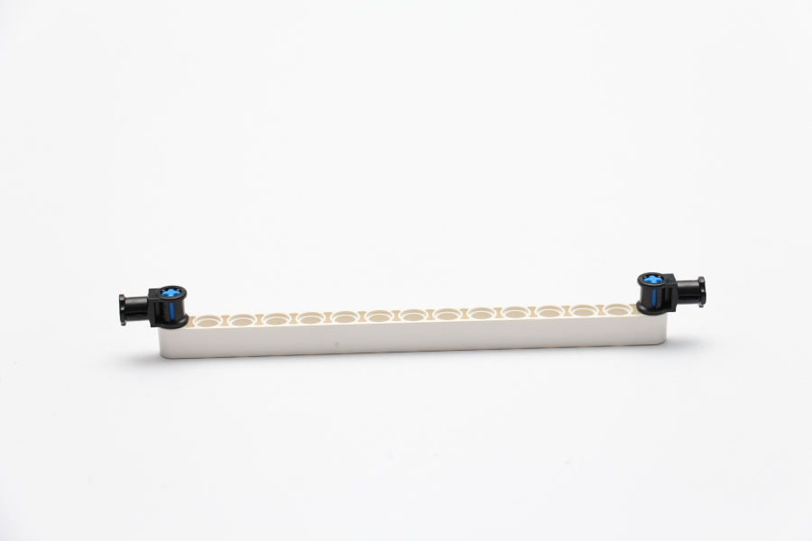
Assembly of the EdHockey Goal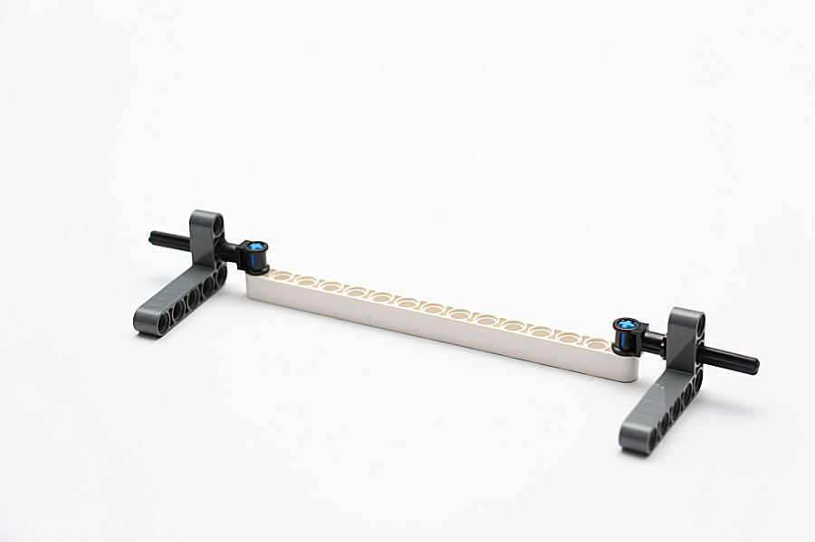Goal

